ESRI/ORURISA/OGISA/ORMAP Parcel Fabric Class Notes 12/10/14

How Do Move Annotation from the Parcel Fabric to ArcMap

The parcel fabric has great annotation tools. Annotation features can be easily moved from the parcel fabric to an ArcMap Geodatabase (ORMAP structure) following these steps.

- Change Parcel Fabric Annotation Properties to include bearings.
- Open Arc Catalog and select the fabric annotation feature class
- Change the annotation property

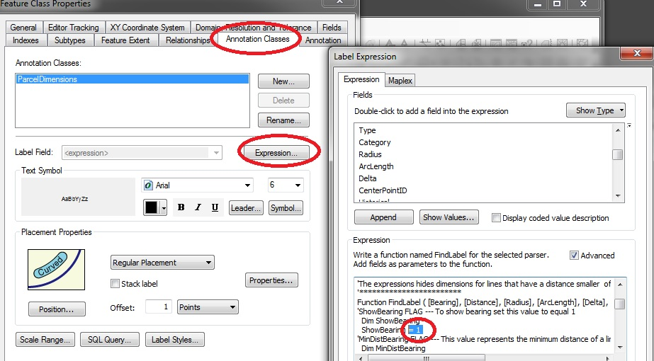

- Edit parcel fabric and select some parcels
- Use the “annotation tool” to update annotation for the selected parcels and save results

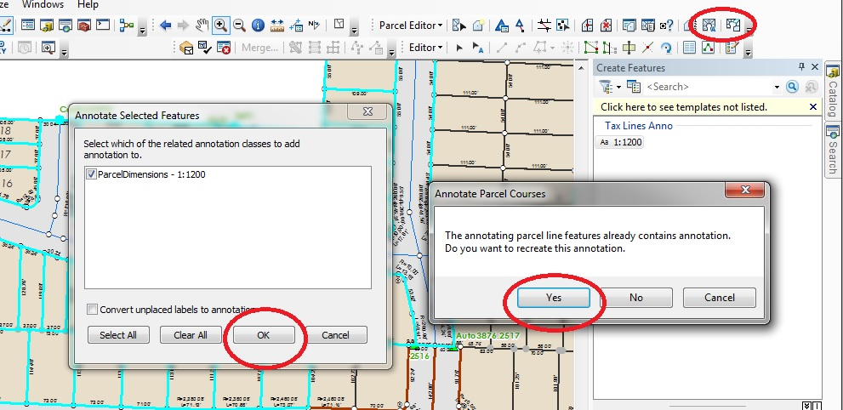

- Add the new annotation layer to an ORMAP edit map file.

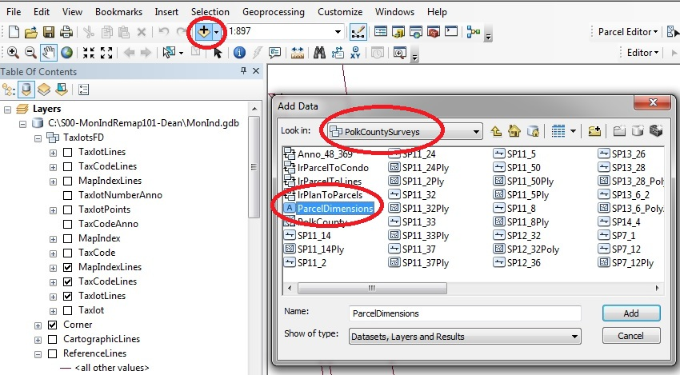

- In edit, select and paste the fabric annotation into the anno100scale feature class

This is a standard cut and paste procedure. You will select the features from the parcel fabric feature class and paste them into ORMAP feature class (anno100scale).

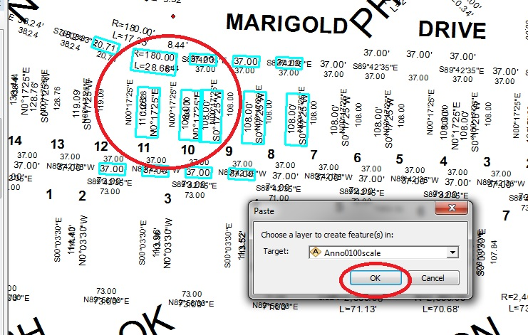

- Calculate the symbol id to be correct for dimensions

Before you paste you should know what the symbolid for your dimensions are. Once you pasted the features, keep them selected and open the attribute table. Use calculate field to update the symbolid to be correct.

